Order Of Service

Singing: Psalm 73—CW page 94

Reading: Psalm 4

Opening Hymn: CW 260

Reading: I Corinthians 6:1-11

Request Hymn: CW Supplement 769

Reading: Matthew 26:57-68

Sermon Hymn: CW 363

Sermon Text: Luke 9:10-17

The Fragments

Prayer

The Apostles’ Creed, TLH page 12

Holy Communion

The Lord's Prayer

The Blessing

Closing Hymn: CW 449

* * * * * * * * * * *

Koinonia Hour
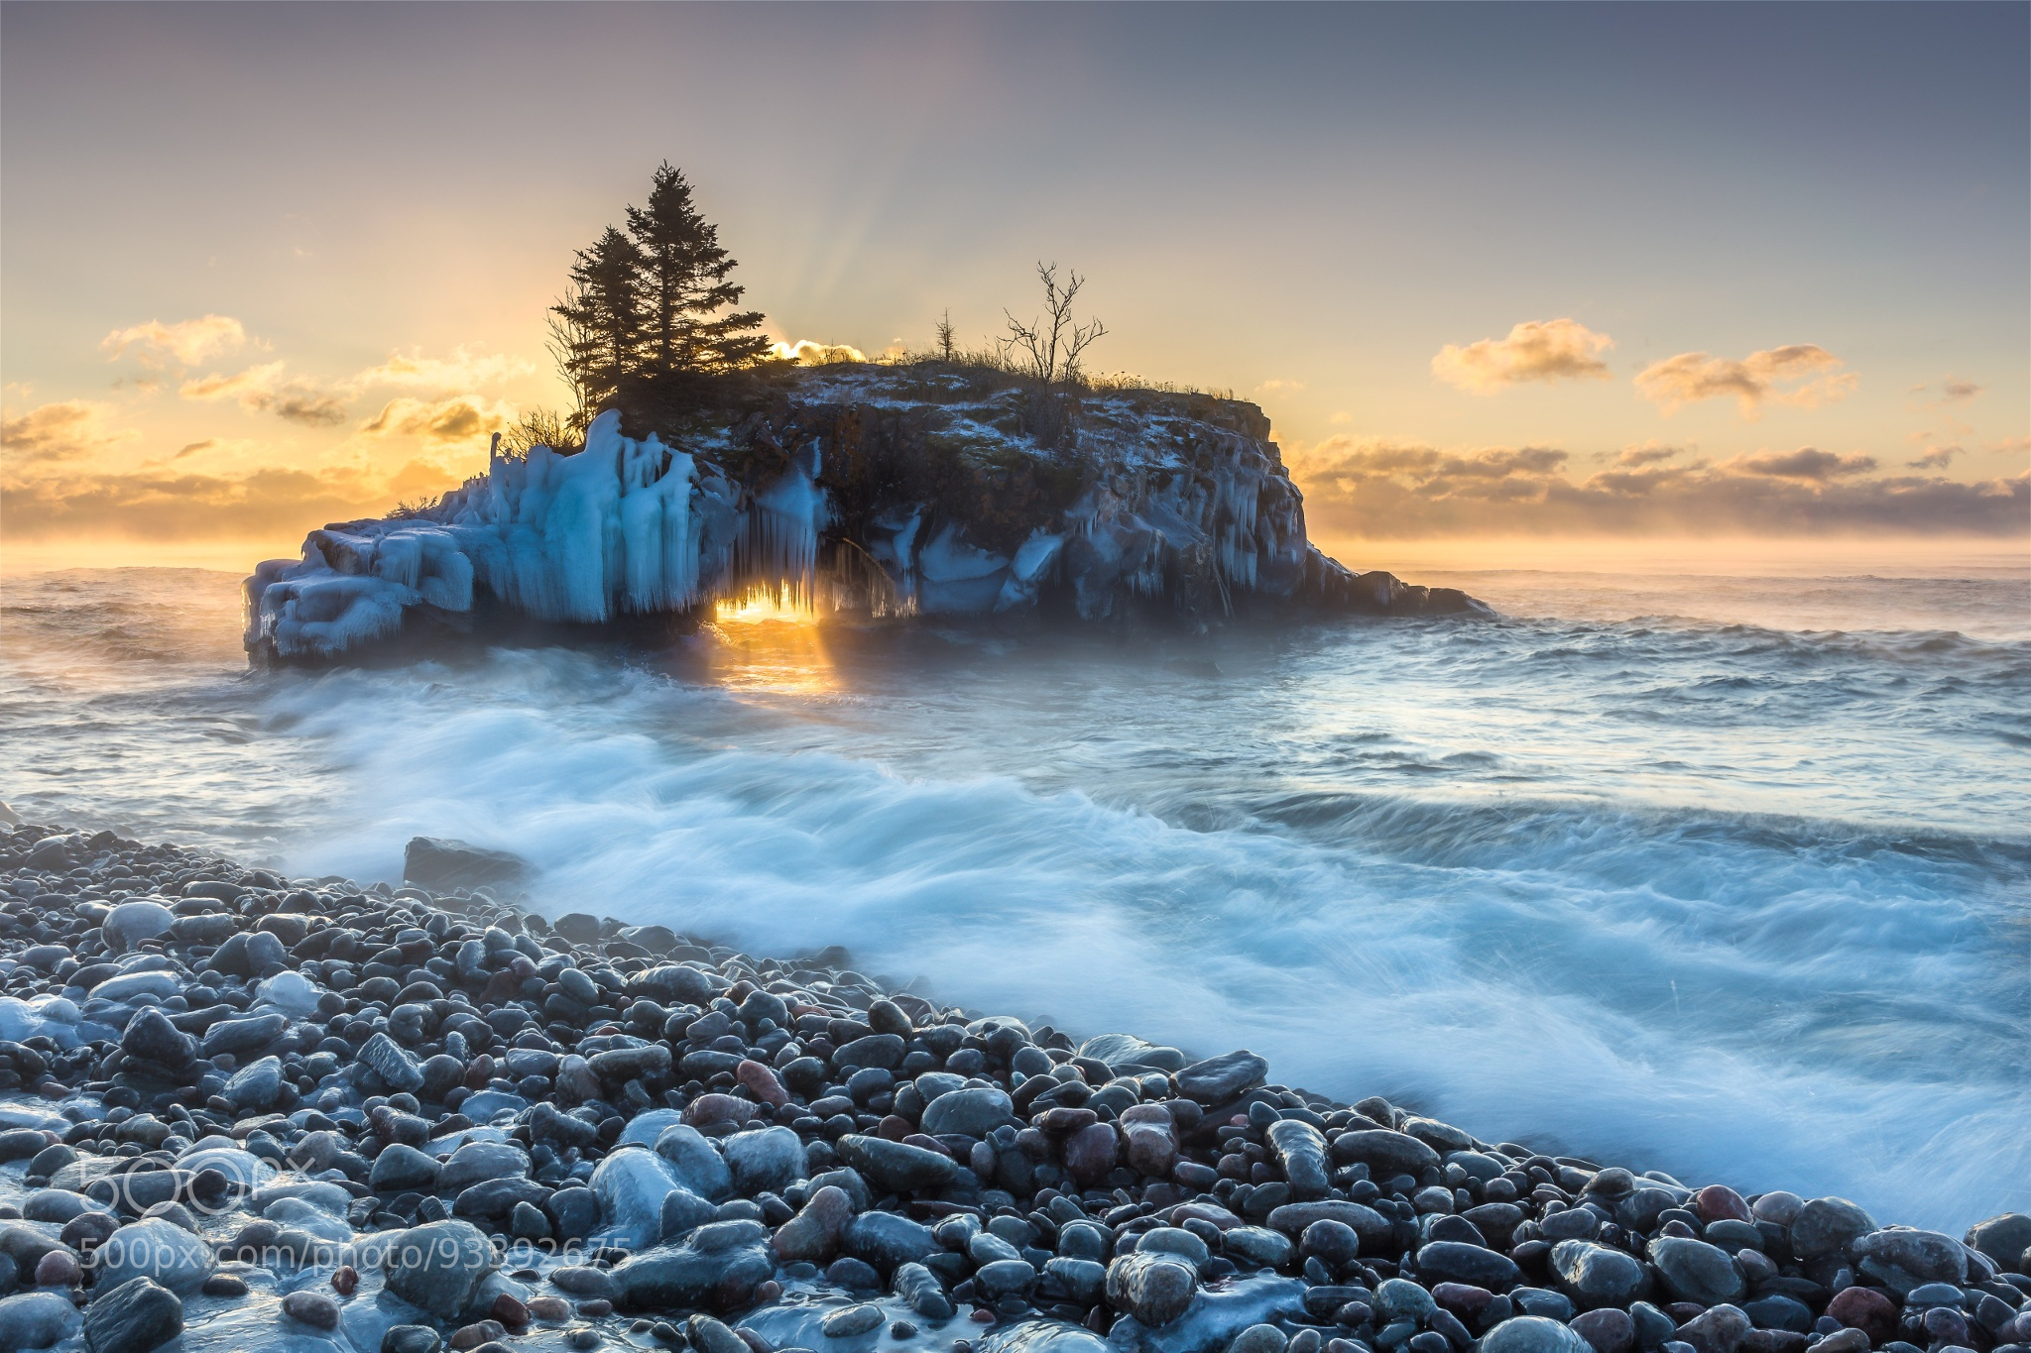

North Shore, Lake Superior

Water
Of
Life

5 September 2021

W A T E R O F L I F E

Independent Christian Church—Conservative Lutheran Doctrine

Worship Service: 9:30 a.m. Bible Study: 10:45 a.m.

Larry Cooper, Pastor E-Mail address:
111 N. Ridge Road lcooper@wateroflife.cc
Coon Valley, WI 54623 Web Site:
www.wateroflife.cc

* * * * * * * * * * * * * * * * * * * * * * * * * * *

Sermon Text: Luke 9:10-17

The Fragments

* * * * * * * * * * * * * * * * * * * * * * * * * * *

10 And the apostles, when they were returned, told him all that they had done. And he took them, and went aside privately into a desert place belonging to the city called Bethsaida.
11 And the people, when they knew it, followed him: and he received them, and spake unto them of the kingdom of God, and healed them that had need of healing.
12 And when the day began to wear away, then came the twelve, and said unto him, Send the multitude away, that they may go into the towns and country round about, and lodge, and get victuals: for we are here in a desert place.
13 But he said unto them, Give ye them to eat. And they said, We have no more but five loaves and two fishes; except we should go and buy meat for all this people.
14 For they were about five thousand men. And he said to his disciples, Make them sit down by fifties in a company.
15 And they did so, and made them all sit down.
16 Then he took the five loaves and the two fishes, and looking up to heaven, he blessed them, and brake, and gave to the disciples to set before the multitude.
17 And they did eat, and were all filled: and there was taken up of fragments that remained to them twelve baskets.

